**MODULE 5 – SPRING CORE AND MAVEN**

**Exercise 1: Configuring a Basic Spring Application**

***File Name: LibraryManagementApplication.java***

package com.library;

import com.library.service.BookService;

import org.springframework.context.ApplicationContext;

import org.springframework.context.support.ClassPathXmlApplicationContext;

public class LibraryManagementApplication {

public static void main(String[] args) {

ApplicationContext context = new ClassPathXmlApplicationContext("applicationContext.xml");

BookService service = context.getBean("bookService", BookService.class);

service.saveBook();

}

}

***File Name: BookRepository.java***

package com.library.repository;

public class BookRepository {

public void saveBook() {

System.*out*.println("Book saved to the database.");

}

}

***File Name: BookService.java***

package com.library.service;

import com.library.repository.BookRepository;

public class BookService {

private BookRepository bookRepository;

public void setBookRepository(BookRepository bookRepository) {

this.bookRepository = bookRepository;

}

public void saveBook() {

bookRepository.saveBook();

}

}

***File Name: ApplicationContext.xml***

<?xml version="1.0" encoding="UTF-8"?>

<beans xmlns="http://www.springframework.org/schema/beans"

xmlns:xsi="http://www.w3.org/2001/XMLSchema-instance"

xsi:schemaLocation="http://www.springframework.org/schema/beans http://www.springframework.org/schema/beans/spring-beans.xsd">

<bean id="bookRepository" class="com.library.repository.BookRepository" />

<bean id="bookService" class="com.library.service.BookService">

<property name="bookRepository" ref="bookRepository" />

</bean>

</beans>

**OUTPUT**

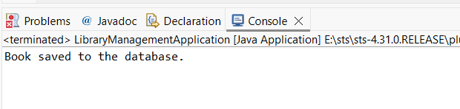

**Exercise 2: Implementing Dependency Injection**

***File name:* *BookService.java* -----it has a setter method**

package com.library.service;

import com.library.repository.BookRepository;

public class BookService {

private BookRepository bookRepository;

public void setBookRepository(BookRepository bookRepository) {

this.bookRepository = bookRepository;

}

public void saveBook() {

bookRepository.saveBook();

}

}

***File name: applicationContext.xml ---- proper wiring***

<?xml version="1.0" encoding="UTF-8"?>

<beans xmlns="http://www.springframework.org/schema/beans"

xmlns:xsi="http://www.w3.org/2001/XMLSchema-instance"

xsi:schemaLocation="http://www.springframework.org/schema/beans http://www.springframework.org/schema/beans/spring-beans.xsd">

<bean id="bookRepository" class="com.library.repository.BookRepository" />

<bean id="bookService" class="com.library.service.BookService">

<property name="bookRepository" ref="bookRepository" />

</bean>

</beans>

**OUTPUT**



**Exercise 3: Implementing Logging with Spring AOP**

***File name: pom.xml--*** ***Add Spring AOP dependency***

<project xmlns="http://maven.apache.org/POM/4.0.0"

xmlns:xsi="http://www.w3.org/2001/XMLSchema-instance"

xsi:schemaLocation="http://maven.apache.org/POM/4.0.0

http://maven.apache.org/xsd/maven-4.0.0.xsd">

<modelVersion>4.0.0</modelVersion>

<groupId>com.library</groupId>

<artifactId>LibraryManagement</artifactId>

<version>1.0-SNAPSHOT</version>

<dependencies>

<!-- Spring Core Dependency -->

<dependency>

<groupId>org.springframework</groupId>

<artifactId>spring-context</artifactId>

<version>5.3.34</version>

</dependency>

<dependency>

<groupId>org.springframework</groupId>

<artifactId>spring-aop</artifactId>

<version>5.3.34</version>

</dependency>

<dependency>

<groupId>org.aspectj</groupId>

<artifactId>aspectjweaver</artifactId>

<version>1.9.21.1</version>

</dependency>

</dependencies>

<build>

<plugins>

<!-- Maven Compiler Plugin -->

<plugin>

<groupId>org.apache.maven.plugins</groupId>

<artifactId>maven-compiler-plugin</artifactId>

<version>3.8.1</version>

<configuration>

<source>1.8</source>

<target>1.8</target>

</configuration>

</plugin>

</plugins>

</build>

</project>

***File Name: applicationContext.xml ----updated xml file for enable AOP***

<?xml version="1.0" encoding="UTF-8"?>

<beans xmlns="http://www.springframework.org/schema/beans"

xmlns:xsi="http://www.w3.org/2001/XMLSchema-instance"

xmlns:aop="http://www.springframework.org/schema/aop"

xsi:schemaLocation="

http://www.springframework.org/schema/beans

http://www.springframework.org/schema/beans/spring-beans.xsd

http://www.springframework.org/schema/aop

http://www.springframework.org/schema/aop/spring-aop.xsd">

<!-- Repository Bean -->

<bean id="bookRepository" class="com.library.repository.BookRepository" />

<!-- Service Bean with DI -->

<bean id="bookService" class="com.library.service.BookService">

<property name="bookRepository" ref="bookRepository" />

</bean>

<!-- AOP Aspect Bean -->

<bean id="loggingAspect" class="com.library.aspect.LoggingAspect" />

<!-- Enable AspectJ auto-proxy support -->

<aop:aspectj-autoproxy />

</beans>

***File name: LoggingAspect.java ---creating aspect class***

package com.library.aspect;

import org.aspectj.lang.ProceedingJoinPoint;

import org.aspectj.lang.annotation.Around;

import org.aspectj.lang.annotation.Aspect;

@Aspect

public class LoggingAspect {

@Around("execution(* com.library.service.*.*(..))")

public Object logExecutionTime(ProceedingJoinPoint joinPoint) throws Throwable {

long start = System.currentTimeMillis();

Object result = joinPoint.proceed(); // call the actual method

long end = System.currentTimeMillis();

System.out.println(joinPoint.getSignature() + " executed in " + (end - start) + "ms");

return result;

}

}

**OUTPUT**

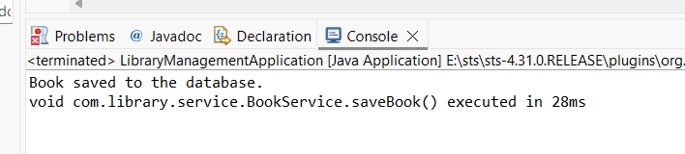

**Exercise 4: Creating and Configuring a Maven Project**

***File name: pom.xml ---updated***

<project xmlns="http://maven.apache.org/POM/4.0.0"

xmlns:xsi="http://www.w3.org/2001/XMLSchema-instance"

xsi:schemaLocation="http://maven.apache.org/POM/4.0.0

http://maven.apache.org/xsd/maven-4.0.0.xsd">

<modelVersion>4.0.0</modelVersion>

<groupId>com.library</groupId>

<artifactId>LibraryManagement</artifactId>

<version>1.0-SNAPSHOT</version>

<dependencies>

<!-- Spring Core -->

<dependency>

<groupId>org.springframework</groupId>

<artifactId>spring-context</artifactId>

<version>5.3.34</version>

</dependency>

<!-- Spring AOP -->

<dependency>

<groupId>org.springframework</groupId>

<artifactId>spring-aop</artifactId>

<version>5.3.34</version>

</dependency>

<!-- AspectJ Weaver (required for AOP to work) -->

<dependency>

<groupId>org.aspectj</groupId>

<artifactId>aspectjweaver</artifactId>

<version>1.9.21.1</version>

</dependency>

<!-- Optional: Spring WebMVC if needed later -->

<dependency>

<groupId>org.springframework</groupId>

<artifactId>spring-webmvc</artifactId>

<version>5.3.34</version>

</dependency>

</dependencies>

<build>

<plugins>

<plugin>

<groupId>org.apache.maven.plugins</groupId>

<artifactId>maven-compiler-plugin</artifactId>

<version>3.8.1</version>

<configuration>

<source>1.8</source>

<target>1.8</target>

</configuration>

</plugin>

</plugins>

</build>

</project>

**OUTPUT**



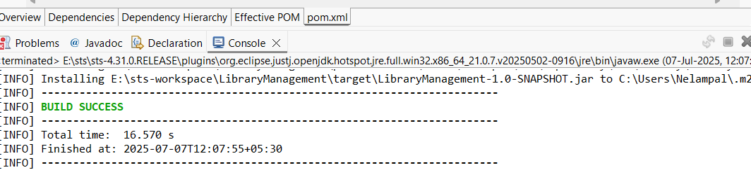

**Exercise 5: Configuring the Spring IoC Container**

***File name: applicationContext.xml***

<?xml version="1.0" encoding="UTF-8"?>

<beans xmlns="http://www.springframework.org/schema/beans"

xmlns:xsi="http://www.w3.org/2001/XMLSchema-instance"

xsi:schemaLocation="

http://www.springframework.org/schema/beans

http://www.springframework.org/schema/beans/spring-beans.xsd">

<!-- Define BookRepository bean -->

<bean id="bookRepository" class="com.library.repository.BookRepository" />

<!-- Define BookService and inject BookRepository -->

<bean id="bookService" class="com.library.service.BookService">

<property name="bookRepository" ref="bookRepository" />

</bean>

</beans>

***File name: BookRepository.java***

package com.library.repository;

public class BookRepository {

public void saveBook() {

System.out.println("Book saved to the database.");

}

}

***File name: BookService.java***

package com.library.service;

import com.library.repository.BookRepository;

public class BookService {

private BookRepository bookRepository;

public void setBookRepository(BookRepository bookRepository) {

this.bookRepository = bookRepository;

}

public void saveBook() {

bookRepository.saveBook();

}

}

***File name: LibraryManagementApplication.java***

package com.library;

import com.library.service.BookService;

import org.springframework.context.ApplicationContext;

import org.springframework.context.support.ClassPathXmlApplicationContext;

public class LibraryManagementApplication {

public static void main(String[] args) {

ApplicationContext context = new ClassPathXmlApplicationContext("applicationContext.xml");

BookService service = context.getBean("bookService", BookService.class);

service.saveBook();

}

}

**OUTPUT**

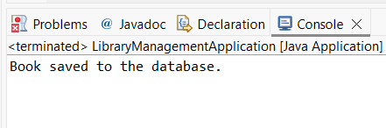

**Exercise 6: Configuring Beans with Annotations**

***File name: applicationContext.xml***

<?xml version="1.0" encoding="UTF-8"?>

<beans xmlns="http://www.springframework.org/schema/beans"

xmlns:xsi="http://www.w3.org/2001/XMLSchema-instance"

xmlns:context="http://www.springframework.org/schema/context"

xsi:schemaLocation="

http://www.springframework.org/schema/beans

http://www.springframework.org/schema/beans/spring-beans.xsd

http://www.springframework.org/schema/context

http://www.springframework.org/schema/context/spring-context.xsd">

<!-- Enable annotation-based scanning -->

<context:component-scan base-package="com.library" />

</beans>

***File name: BookRepository.java***

package com.library.repository;

import org.springframework.stereotype.Repository;

@Repository

public class BookRepository {

public void saveBook() {

System.*out*.println("Book saved to the database.");

}

}

***File name: BookService.java***

package com.library.service;

import com.library.repository.BookRepository;

import org.springframework.beans.factory.annotation.Autowired;

import org.springframework.stereotype.Service;

@Service

public class BookService {

@Autowired

private BookRepository bookRepository;

public void saveBook() {

bookRepository.saveBook();

}

}

***File name: LibraryManagementApplication.java***

package com.library;

import com.library.service.BookService;

import org.springframework.context.ApplicationContext;

import org.springframework.context.support.ClassPathXmlApplicationContext;

public class LibraryManagementApplication {

public static void main(String[] args) {

ApplicationContext context = new ClassPathXmlApplicationContext("applicationContext.xml");

BookService service = context.getBean(BookService.class);

service.saveBook();

}

}

**OUTPUT**

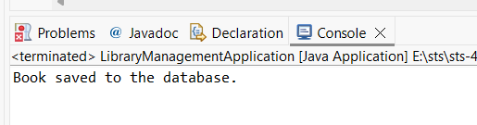

**Exercise 7: Implementing Constructor and Setter Injection**

***File name: applicationContext.xml***

<?xml version="1.0" encoding="UTF-8"?>

<beans xmlns="http://www.springframework.org/schema/beans"

xmlns:xsi="http://www.w3.org/2001/XMLSchema-instance"

xsi:schemaLocation="http://www.springframework.org/schema/beans

http://www.springframework.org/schema/beans/spring-beans.xsd">

<!-- Constructor + Setter Injection -->

<bean id="bookRepository" class="com.library.repository.BookRepository" />

<bean id="bookService" class="com.library.service.BookService">

<constructor-arg ref="bookRepository" />

<property name="serviceType" value="Premium Service" />

</bean>

</beans>

***File name: BookService.java***

package com.library.service;

import com.library.repository.BookRepository;

public class BookService {

private BookRepository bookRepository;

private String serviceType;

// Constructor Injection

public BookService(BookRepository bookRepository) {

this.bookRepository = bookRepository;

}

// Setter Injection

public void setServiceType(String serviceType) {

this.serviceType = serviceType;

}

public void saveBook() {

System.*out*.println("Service Type: " + serviceType);

bookRepository.saveBook();

}

}

***File name: LibraryManagementApplication.java***

package com.library;

import com.library.service.BookService;

import org.springframework.context.ApplicationContext;

import org.springframework.context.support.ClassPathXmlApplicationContext;

public class LibraryManagementApplication {

public static void main(String[] args) {

ApplicationContext context = new ClassPathXmlApplicationContext("applicationContext.xml");

BookService service = context.getBean(BookService.class);

service.saveBook();

}

}

**OUTPUT**

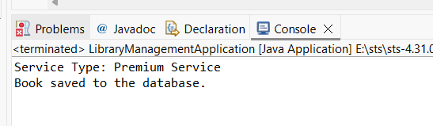

**Exercise 8: Implementing Basic AOP with Spring**

***File name: pom.xml***

<project xmlns="http://maven.apache.org/POM/4.0.0"

xmlns:xsi="http://www.w3.org/2001/XMLSchema-instance"

xsi:schemaLocation="http://maven.apache.org/POM/4.0.0

http://maven.apache.org/xsd/maven-4.0.0.xsd">

<modelVersion>4.0.0</modelVersion>

<groupId>com.library</groupId>

<artifactId>LibraryManagement</artifactId>

<version>1.0-SNAPSHOT</version>

<dependencies>

<!-- Spring Core -->

<dependency>

<groupId>org.springframework</groupId>

<artifactId>spring-context</artifactId>

<version>5.3.34</version>

</dependency>

<!-- Spring AOP -->

<dependency>

<groupId>org.springframework</groupId>

<artifactId>spring-aop</artifactId>

<version>5.3.34</version>

</dependency>

<!-- AspectJ Weaver (required for AOP to work) -->

<dependency>

<groupId>org.aspectj</groupId>

<artifactId>aspectjweaver</artifactId>

<version>1.9.21.1</version>

</dependency>

<!-- Optional: Spring WebMVC if needed later -->

<dependency>

<groupId>org.springframework</groupId>

<artifactId>spring-webmvc</artifactId>

<version>5.3.34</version>

</dependency>

</dependencies>

<build>

<plugins>

<plugin>

<groupId>org.apache.maven.plugins</groupId>

<artifactId>maven-compiler-plugin</artifactId>

<version>3.8.1</version>

<configuration>

<source>1.8</source>

<target>1.8</target>

</configuration>

</plugin>

</plugins>

</build>

</project>

***File name: LoggingAspect.java***

package com.library.aspect;

import org.aspectj.lang.JoinPoint;

import org.aspectj.lang.annotation.After;

import org.aspectj.lang.annotation.Aspect;

import org.aspectj.lang.annotation.Before;

@Aspect

public class LoggingAspect {

@Before("execution(* com.library.service.*.*(..))")

public void logBefore(JoinPoint joinPoint) {

System.*out*.println("Before: " + joinPoint.getSignature().getName());

}

@After("execution(* com.library.service.*.*(..))")

public void logAfter(JoinPoint joinPoint) {

System.*out*.println("After: " + joinPoint.getSignature().getName());

}

}

***File name: applicationContext.xml***

<?xml version="1.0" encoding="UTF-8"?>

<beans xmlns="http://www.springframework.org/schema/beans"

xmlns:xsi="http://www.w3.org/2001/XMLSchema-instance"

xmlns:aop="http://www.springframework.org/schema/aop"

xsi:schemaLocation="

http://www.springframework.org/schema/beans

http://www.springframework.org/schema/beans/spring-beans.xsd

http://www.springframework.org/schema/aop

http://www.springframework.org/schema/aop/spring-aop.xsd">

<!-- Enable AOP -->

<aop:aspectj-autoproxy />

<!-- Define Repository -->

<bean id="bookRepository" class="com.library.repository.BookRepository" />

<!-- Define Service with constructor and setter injection -->

<bean id="bookService" class="com.library.service.BookService">

<constructor-arg ref="bookRepository" />

<property name="serviceType" value="Premium Service" />

</bean>

<!-- Register Aspect -->

<bean id="loggingAspect" class="com.library.aspect.LoggingAspect" />

</beans>

**OUTPUT**

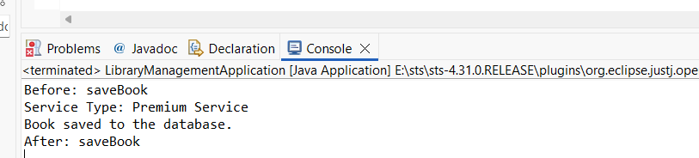

**Exercise 9: Creating a Spring Boot Application**

***File name: BookController.java***

package com.library.controller;

import com.library.entity.Book;

import com.library.repository.BookRepository;

import org.springframework.beans.factory.annotation.Autowired;

import org.springframework.web.bind.annotation.*;

import java.util.List;

@RestController

@RequestMapping("/books")

public class BookController {

@Autowired

private BookRepository bookRepository;

@GetMapping

public List<Book> getAllBooks() {

return bookRepository.findAll();

}

@PostMapping

public Book addBook(@RequestBody Book book) {

return bookRepository.save(book);

}

@GetMapping("/{id}")

public Book getBookById(@PathVariable int id) {

return bookRepository.findById(id).orElse(null);

}

@PutMapping("/{id}")

public Book updateBook(@PathVariable int id, @RequestBody Book book) {

book.setBookId(id);

return bookRepository.save(book);

}

@DeleteMapping("/{id}")

public void deleteBook(@PathVariable int id) {

bookRepository.deleteById(id);

}

}

***File name: Book.java***

package com.library.entity;

import jakarta.persistence.Entity;

import jakarta.persistence.Id;

@Entity

public class Book {

@Id

private int bookId;

private String title;

private String author;

// Getters and Setters

public int getBookId() { return bookId; }

public void setBookId(int bookId) { this.bookId = bookId; }

public String getTitle() { return title; }

public void setTitle(String title) { this.title = title; }

public String getAuthor() { return author; }

public void setAuthor(String author) { this.author = author; }

}

***File name: BookRepository.java***

package com.library.repository;

import com.library.entity.Book;

import org.springframework.data.jpa.repository.JpaRepository;

public interface BookRepository extends JpaRepository<Book, Integer> {

}

***File name: application.properties***

spring.datasource.url=jdbc:h2:mem:librarydb

spring.datasource.driverClassName=org.h2.Driver

spring.datasource.username=sa

spring.datasource.password=

spring.jpa.database-platform=org.hibernate.dialect.H2Dialect

spring.jpa.hibernate.ddl-auto=update

spring.h2.console.enabled=true

server.port=8081

***File name: LibraryManagemntApplication***

package com.library;

import org.springframework.boot.SpringApplication;

import org.springframework.boot.autoconfigure.SpringBootApplication;

@SpringBootApplication

public class LibraryManagementApplication {

public static void main(String[] args) {

SpringApplication.*run*(LibraryManagementApplication.class, args);

}

}

**OUTPUT**